How to Approve New Members in VHASS
- Go to www.vhass.org and log in to your account.
- Under the “Administration” tab, click on “Membership Management”
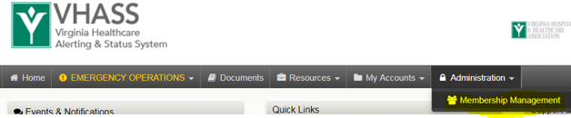
- On the next page, click on “View Members”. Then, scroll to bottom to identify members in the system. Members with a yellow circle under the “approved column” are pending approval. Click the yellow icon.
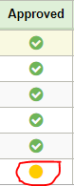
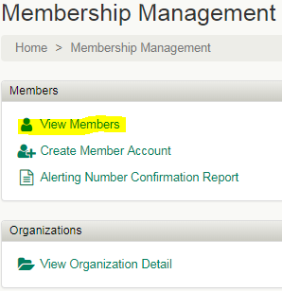

- Follow the steps on the subsequent pages to approve the account.
Notes:
- On Step 3 of the approval process, check the user’s name if you wish to enable them to receive VHASS text message alerts.
- On Step 4 of the approval process, give the user “Emergency Operations Read/Write Access” permissions if you wish for them to be able to use the VHASS Events Module or complete any emergency reporting required by the RHCC.
- On Step 6 of the approval process, give the user “Input and View” permissions if you would like for them to be able to enter patient tracking information during an MCI.

