Sometimes it is necessary and convenient to link multiple user/member accounts together as you may be a member of several different organizations. Linking multiple user accounts will allow you to log into the VHASS web application with any one of your linked accounts and easily switch between these accounts, as if logging out and logging back in however without that hassle.

If you have not already registered for the VHASS website for each organization that you belong to, please go to www.vhass.org In the upper-right hand corner there will be a “Register Now” button.
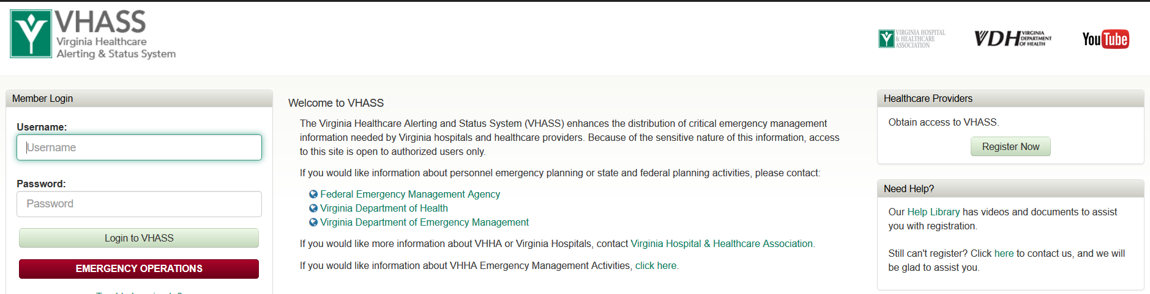

Register a membership account for any organizations that you belong to.
Fields within the website in yellow are required fields.
Fields within the website in white are nice to have information.

You will get an e-mail once the registration for each organization is submitted and another e-mail once approved by one of the designated organization contacts.

Please remember that usernames have to be different but passwords can be the same.
(for example: you could use your last name and the initials of the organization for the username)

Once the account(s) are approved – to link the accounts/toggle between the organizations.
Log back onto the VHASS website. Go to My Accounts > Manage Linked Accounts and search for your other account(s) and then link requests to those accounts.
Do not request to link to an account that you do not belong to.
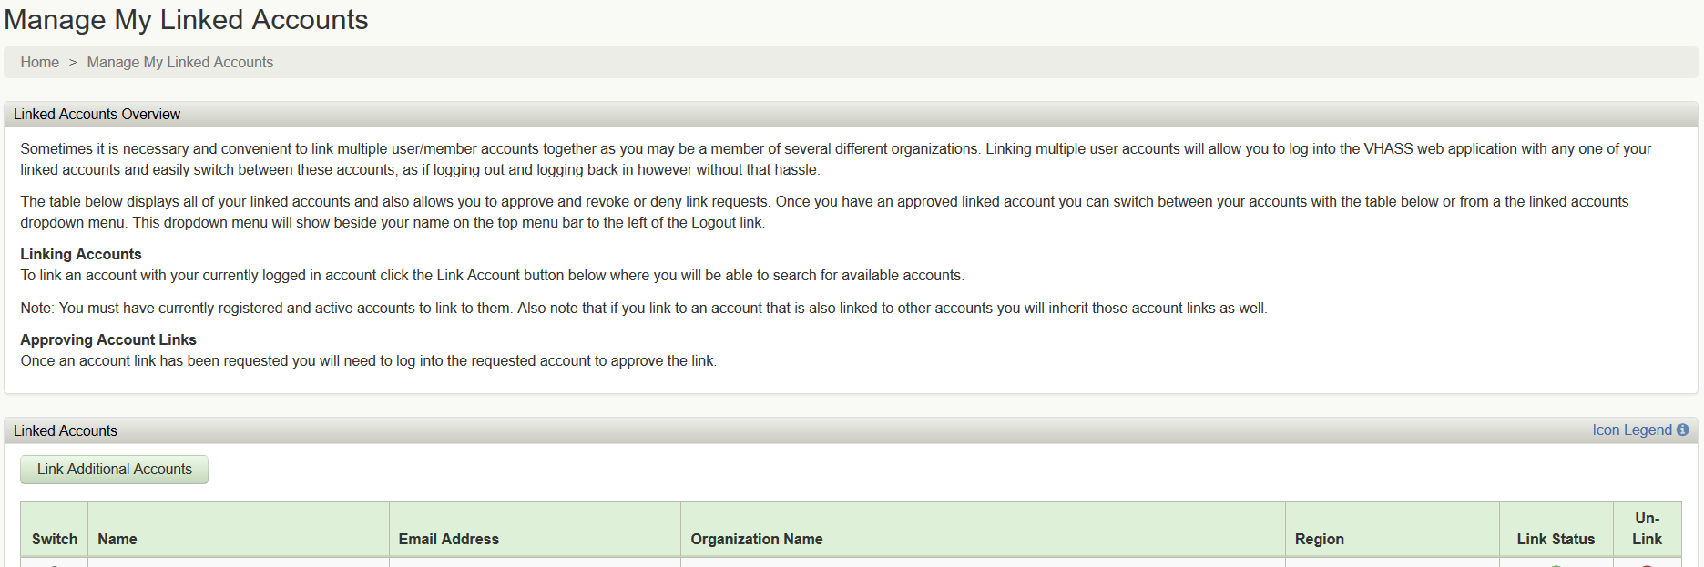

You will need to log off and log in to each of the other account(s).

Once you log into that account, you will be notified with a popup message of the pending linked account request where you can approve or deny it.
If you ever receive a request to link an account that you do not recognize, deny that request.

Once the linked account request is approved, you will have new option in the upper-right hand comer called “Linked Accounts”. Click this option and then you can choose the other account(s) that you would like to toggle to.
