How to Setup Your Alerting Profile in VHASS
- Go to www.vhass.org and log in to your account.
- Under the “My Accounts” tab, click on “Personal Information”
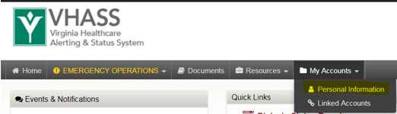
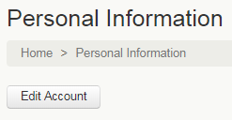
- On the next page, click on the “Edit Account” button.

- Ensure all information is up to date. Proceed to Step/Page 3: “Alerting Contact Information”. Enter your carrier information and cell phone number. After you have entered your cell phone number, click anywhere outside of the entry field in order to reveal an option to click “Send Verification Code”. Click to send a text message with a verification code to your phone. Enter the code into the field that appears.
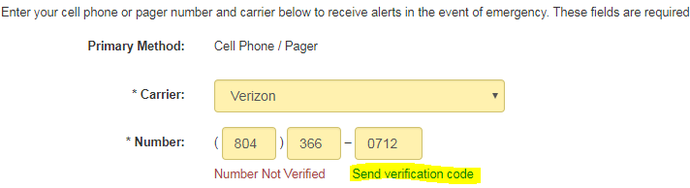

- Scroll to the bottom. Check the cell phone text message acknowledgement and press continue
