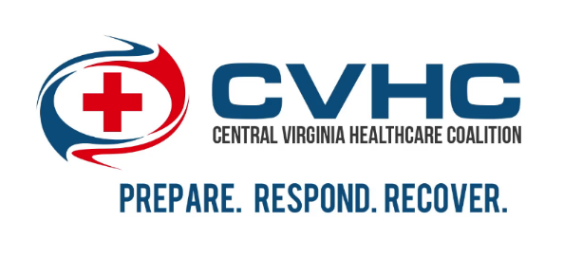
CVHC 2019 Exercise Series
AAR Post-It Notes: February 26/27/28
UP(s)
- well-formed EOP
- MOU with sister facilities
- communication resiliency
- transfer agreements
- notification systems in place
- resources - generators
- annexed high heat plan
- job aids
- shelter annex/plan
- evac/relocation plans
- comms plan
- shelter in place plan
- internal comms
- staff and patients
- ttx collaboration of alternate org types
- have emergency contacts resources list
- EOP is available to all
- pt. education and outreach
- schedule adaptation
- water trucks on standby
- back up / transfer locations
- education plans for patient and staffing
- fuel topped off
- redundant contacts/resources for fuel
- early - preplanned dialysis plans
- continuity of ops: self-reliant able to provide care and services, despite emergency event
- enterprise / corporate support
- patient communication
- 4-day supply on hand
- command center set up
- staff alerting
- 100% covered by generator/emergency power
- 4-6 days of fuel
- good with VHASS
- strong networking
- 72-96 charts are good
- adaptation
- knowledge of plan
- staffing levels
- communication with clients
- corporate ICS
- all registered and updated in VHASS
- whole building generators
- MOUs
- food and water always adequately stocked
- pre-planning of early notice event
- sharing information
- heat stress specific plan
- mous
- staffing levels
- big campus allows for movement areas
- sit reps
- website for documents availability
- corporate support
Down(s)
- need more agreement plans
- staffing
- mass communication
- emergency medication plans
- ems transport for dialysis patients to acute care hospital or other dialysis centers
- communication redundancies
- haven’t tested MOUs/ agreements
- no specific annex on heat
- need firm temperature measurement to place in evac plan
- access to Hics forms / job aids
- practice and plan of delegation of incident command
- resources on the units / in the stations
- patient transportation
- bio waste / waste management
- lack of leadership staff for extended events
- HICS familiarization
- comms plan needs improved
- "off shift" plan if event occurs after business hours
- VHASS update of bio
- staffing location / arrival to facility plan
- don’t know how to obtain dialysis kits
- leadership ICS training
- staffing protocols
- external comms plan
- build three levels of leadership to EOP
- shorthanded staffing
- resource allocation and delivery
- comms plan needs improved
- knowing and communicating with transport services
- staff personal readiness plans, esp those with children
- transportation logistics
- need agreement/relationship with facilities who can take high level acuity
- redundant locations
- need generator
- practice pt. schedule changes
- gen staff communication not just leadership
- external contacts to vendors and back up vendors
- knowing who has what in the event of a supply shortage
- inadequate resource depth for ics
- more vendors
- educating on the plans written
- are all the EOPs the same in our facilities
- hepatitis B status of dialysis
- 3 deep in chain of command
- all facilities need back up electricity, is this noted in EOP
- knowing what resources are available
- home health and hospice communication
- continuous staff training on the EOP
- who gets shared resources first?
- school bus use?
- visual emergency flip book
- patient tracking needs practiced and improved
- transportation logistics
- generators only in some facilities
- inlet water temp
- heat pump
- child care for staff
- practice with emergency equipment
- need more drills
- storage space for supplies
- staff transportation plan
- evacuation plan and exercise
- can’t sustain 96*
- need to update P&P manual
- evac plans needs more specifics
- how to increase staff up and down / what parameters
- increasing and decreasing ICS
- need to add RHCC 1-800 # to comms plan
- need dominion power contact list in comms plan
- list of emergency contacts (DME)
- having list of account numbers/vendors/contacts
- need a high heat plan
- no reserve staff

