RPA Surge and Evac Assessment Notes
October 30, 2018
Hospitals in attendance:
- VCU
- St. Francis
- John Randolph
- Chippenham
- Johnston Willis
- VCU CMH
- Henrico Doctors Parham
- Retreat Hospital
- Southside Regional Medical Center
- St. Mary’s
- Richmond Community

- In a Surge event Actions Order:
- Fill open bed
- Census Reduction
- Cancel Electives / OP procedures
- Rapid D/C
- FOLLOW RP SURGE ADVICE

- In each area there is a charge nurse guide that will identify:
- Area
- Timeframe
- Resources
- Staffing
- Beds
- Equipment
*The type of patient may dictate additional specialty resources.

- Surge Command Center Tool:
  - Prioritize what space will be used
  - Highest to lowest
  - Operational issues that will have
  - How many beds
  - List the current census
  - List open beds
  - List pts ready for d/c or transfer
  - List what staff and resources they can provide
  - What resources will be needs

- Excel spreadsheet so can populate in real time
- Can take this an PREPOPULATE this for specific events … from THIRA/HVA and preplan, can use this for planning/exercise / real event response.

  - External Event
    - MCI
    - Weather
    - Burns
    - Trauma
  - Internal Event
    - Fire / smoke
REGIONAL INFO:

- Beds
  - 3815 Total in region daily
    - 2416 monitored
  - 1845 Total Surge
    - 2-4 hrs: 43 beds
    - 24 hrs: 650 beds
    - Extended hrs: 931 beds

- Equipment (860 needs)
  - Beds, stretchers, iso: 114
  - O2 splitter and tubing: 107
  - Bells: 514
  - Suction: 36
  - Cardiac monitors: 414
  - Staff needs to surge (IP areas only)
    - CNA/PCT: 14
    - CC RN: 36
    - RN: 128
    - Mental Health: 5
    - If you need specialty RNs these are not included in the above (ex: neonatal / specialty)
  - Oxygen regulators – vendor may supply with tanks and need your own regulators
  - Vertical Evacuation Equipment SNAPSHOT
    - Sleds
    - Chairs
    - For critical care areas
    - Training
    - Storage
    - Not to be used during a fire / urgent / rapid to remove out of danger
    - Can be used if vertical evacuate down the stairs in teams
    - Best practice from RPA is centrally stored (highest level if in two towers / or lower) if meant to be deployed and used by trained staff
  - Evacuation Needs
    - 82 critical care transport (7%)
    - 1
    - 6
    - 755 ALS (27%)
    - 27 ALS bari
    - 614 BLS (22%)
    - 14 BLS bari
    - 478 W/C transport (17%)
    - 2 W/C bari
    - 800 Evac bus / van
    - 109 vents
    - 236 direct ops
    - >800 on continuous oxygen
    - Bariatric (1.5%)

Staging and D/C areas:

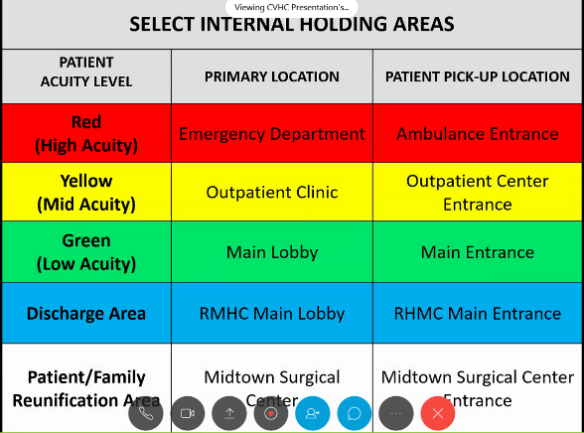
- Select Internal holding areas… not all in one location to avoid chaos
- Create floor plans
- Identify stairwells to be used by patients and separate for staff / first responders
- If it’s isolated event EMS/Fire may be able to help with manpower and equipment
- BUT Staff have to be prepared and trained without any outside assistance (ex: tornado and whole community response)
- Evac Team / bucket brigade
  - Stair group
  - Evac floor group
  - Elevator group
  - Discharge floor group

- Where can they go (reference tool)
  - Start with highest level of acuity and locate regional beds
  - Utilize RHCC
    - Identify Mutual Aide: LTC Wheelchair Vans / GRTC for ambulatory / taxis lyft or uber

