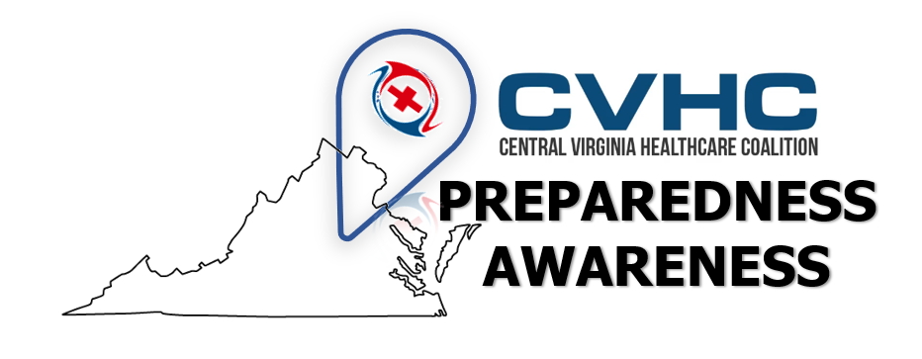

Volume 1. Issue 1
June 25, 2019

“Community Resource: CVEMA”

Central Virginia Emergency Management Alliance (CVEMA) has been re-branded! CVEMA is now The Emergency Management Alliance of Central Virginia.

The Emergency Management Alliance of Central Virginia is a collaborative board and committee of jurisdictional emergency managers and community stakeholders who work through the Richmond Regional Planning District (PlanRVA) as a coalition of professionals dedicated to helping the residents of Central Virginia prepare for and recover from disasters. Central Virginia Healthcare Coalition (CVHC) is an active member of this coalition and involved in the planning, awareness, and sharing of resources and efforts in emergency preparedness for our region.

The re-branding of this committee allows overall alignment with federal preparedness initiative "Ready.gov" for "CVEMA" and each county/city/jurisdiction served within it.

For more information visit: https://planrva.org/emergency-management-home/ , or ask your local Emergency Manager on how you can get involved in your localities efforts!

As always, CVHC will continue to report any shared information about this committee and others that we serve on during our monthly meetings (Fourth Friday of every Month)!

