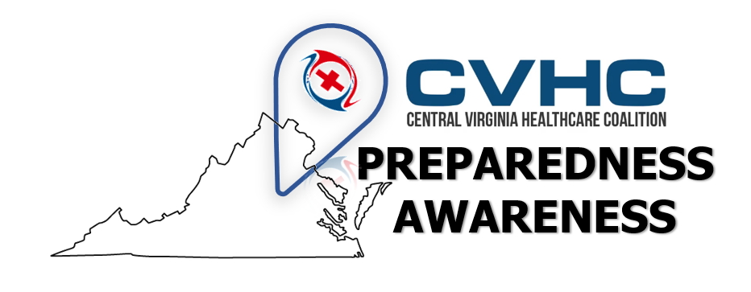

Volume 1. Issue 2
June 26, 2019
“Community Resource: Department of Blind and Vision Impaired”

Have you heard of DBVI? DBVI is The Virginia Department for the Blind and Vision Impaired, and it is housed right here in Richmond!

“About DBVI
The Department for the Blind and Vision Impaired (DBVI) is committed to providing quality services to assist Virginia's citizens who are blind, deafblind or vision impaired in achieving their maximum level of employment, education, and personal independence. The department provides an array of specialized services to blind Virginians of all ages to assist them in attaining the skills, confidence and positive outlook that are critical to independence.
Our primary focus is to assist blind Virginians in achieving quality employment outcomes. Vocational evaluation, job training, job development, placement, follow-up and other services are provided to assist consumers in obtaining jobs in the public and private sectors. Training for and employment as food service managers and vendors are available in cafeterias, snack bars, and other vending facilities in public and private buildings. The Virginia Industries for the Blind provides another employment option for blind Virginians at its two plant locations in Charlottesville and Richmond, its satellite store operations and administrative service positions across the Commonwealth.”

FOR MORE INFORMATION VISIT DBVI's Website: https://www.vdbvi.org/

