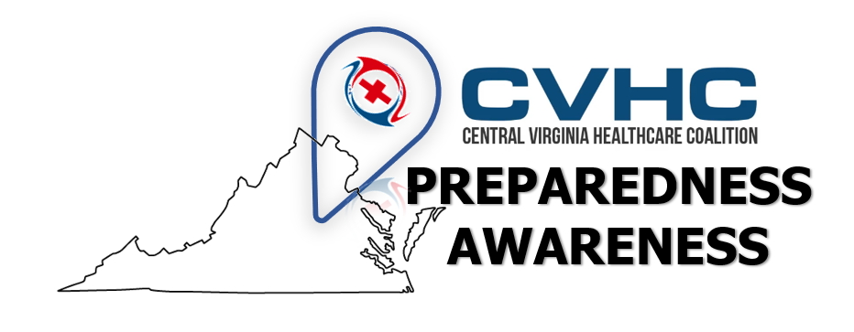

Volume 1. Issue 5.
“Legionella Bacteria and Legionnaires Disease”
Publication Date: August 7, 2019

Legionella Bacteria– Potential Outbreak in Central Region, Virginia

Legionella is a bacteria found to be naturally occurring in streams and rivers. When it is aerosolized by man-made machines such as pools, fountains, HVAC units, misting devices, or cooling towers it can cause the respiratory illness named Legionnaires Disease in at risk persons. Legionnaires’ Disease causes pneumonia-like symptoms.

Signs and symptoms of Legionnaires’ disease can include:
- Cough
- Muscle aches
- Fever
- Shortness of breath
- Headache

Diagnosis is confirmed by chest x-rays and physician exam to check for pneumonia. As well as urine and sputum culturing for Legionella.

Additional Causes, Risks, Signs and Symptoms, Diagnosis and Treatment of Legionnaire’s can all be found on the attached CDC LEGIONNAIRES’ DISEASE FACT SHEET (PDF). CLICK LINK or Pictured below

CVHC Specific: Chesterfield Health Department is coordinating sample testing in the potential outbreak area in collaboration with the CDC. A formal media release from VDH is being drafted and will be sent via typical distribution pathways from the state office. Until that media release is posted, VDH has shared the following public information regarding the current status of Legionella Cases in Central Region for CHVC Members review:
- 11 confirmed cases of Legionella after extensive investigation
- Locality is the commonality: NE Chesterfield Co.
- Most healthy people do not get sick. Those who are elderly, with chronic illnesses, or immune-compressed are at greater risk.
- CDC is being consulted on this effort to identify the environmental source

For more information please speak with your local VDH Health District Coordinator.

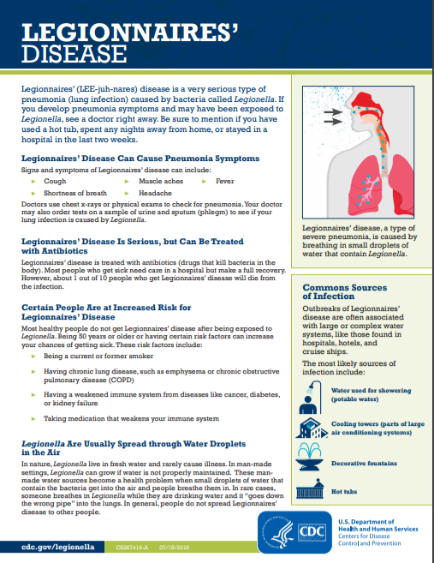Sources:

Legionnaires Disease and Pontiac Fever | Legionella | CDC. (n.d.). Retrieved August 7, 2019, from https://www.cdc.gov/legionella/index.html

Virginia Department of Health. (n.d.). Retrieved August 7, 2019, from http://www.vdh.virginia.gov/environmental-epidemiology/waterborne-hazards-control/legionella/

