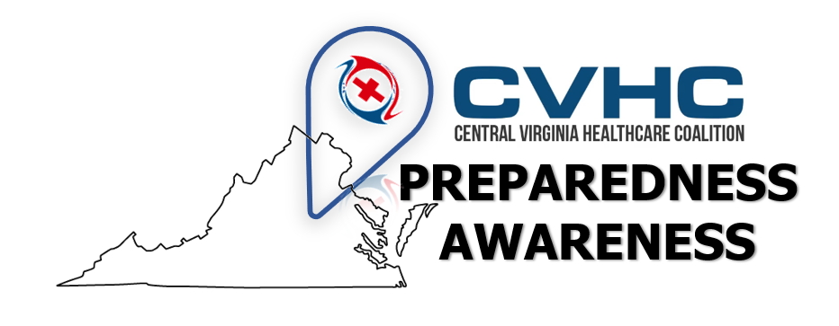
Volume 1. Issue 6.
“Hurricane Preparedness – Before During and After”
Publication Date: August 30, 2019

Hurricane Preparedness – Before During and After
Hurricanes are large storm systems formed over warm oceans and track toward land. These systems can cause powerful winds, heavy rainfall, storm surges, flooding, increased rip currents, and the formation of tornadoes (often multiple). Secondary effects of these storms will result in power outages, downed trees and erosions or landslides.
Hurricane season runs from June 1 to November 30 for the East Coast (Atlantic) of the United States and May 15 to November 30 for the West Coast (Pacific). Hurricanes can span across >100 miles inland and are most active in September.
Prepare NOW before a hurricane, Survive during and, Stay Safe after a Hurricane!
Before a Hurricane: PREPARE
- Know your area’s risk of hurricanes.
  - Become familiar with your evacuation zone, the evacuation route, and shelter locations.
    - VDEM’s KNOW YOUR ZONE (click for link)
  - Sign up for your community’s warning system.
- Stay alert to updates and warning
  - The Emergency Alert System (EAS)
  - National Oceanic and Atmospheric Administration (NOAA) Weather Radio
- Gather supplies, medicines, food for all persons and pets, to last 3 days
  - Need help knowing what to put in your preparedness kit? : EmergencySuppliesKit
- Locate a safe shelter – interior room without windows on the lowest level not prone to flooding
  - Practice going to the shelter / safe space for high winds
- Make a communications plan with family members
  - Plan what time you will all check in and via what method (ex: text or call)
  - Keep phone numbers written down in your preparedness bag incase of cellular power/use loss
- Prepare for prolonged power outages
  - Fuel up your vehicles and generators
  - Charge cellular phones and flashlights or medical devices
  - Turn your refrigerator or freezer to the coldest setting and open only when necessary.
  - Keep a thermometer in the refrigerator
  - Keep important documents in a safe place or create password-protected digital copies.
- Prepare your home.
  - Declutter drains and gutters.
  - Install valves in plumbing to prevent backups.
  - Review insurance policies.
  - Bring loose yard debris, decorations, and tools inside. These items can become projectiles in high winds. Do not bring in gasoline or propane tanks.
  - If you are in an immediate impact zone: Cover your home windows with permanent shutters or wood boards
During a Hurricane: SURVIVE
- Evacuate or Shelter in Place
  - Protect yourself from high winds and flying debris by taking refuge in an interior room of your house/building without windows.
  - Evacuate if you are advised to do so.
  - If trapped in a building by flooding, go to the highest level of the building. Do not climb into a closed attic. You may become trapped by rising flood water.
- Be aware of emergency alerts and alarms
- Never use a generator indoors or near windows
- “Turn Around, Don’t Drown” – never drive/walk/swim through flood waters of an unknown level
- Stay off bridges over fast-moving water
After a Hurricane: STAY SAFE
- Listen to authorities for information and special instructions.
- Be careful during clean-up.
  - Wear protective clothing and work with someone else.
  - Do not touch electrical equipment if it is wet or if you are standing in water. If it is safe to do so, turn off electricity at the main breaker or fuse box to prevent electric shock.
- Avoid wading in flood water, which can contain dangerous debris. Underground or downed power lines can also electrically charge the water.
- Save phone calls for emergencies. Phone systems are often down or busy after a disaster. Use text messages or social media to communicate with family and friends.
- Stay alert for Storm Surge!
  - Storm Surge is the leading cause of hurricane-related deaths in the USA (ready.gov).
  - A storm surge occurs when water from the ocean is pushed toward the shore and lands by the forceful winds of the hurricane.
  - Storm Surge occurs rapidly causing extreme flooding even many miles inland causing destruction of property and life.
  - Storm surge can cause the undermining of highways/bridges/roads and foundations
- Assess the effects of persons and property
  - Persons – seek medical care and relocation if necessary
  - Property – assess and document for damage
    - One inch of water in your home can cause approximately $25,000 of damage.
    - Flood damage is not typically covered in basic homeowners or renter’s insurance
    - Document any property damage with photographs. Contact your insurance company for assistance.
Sources:
Department of Homeland Security. Ready.gov: Hurricanes. Retrieved from https://www.ready.gov/hurricanes
Skywarn, Owlie. National Weather Service. Emergency Supplies Kit. Retrieved from https://www.weather.gov/owlie/emergencysupplieskit
Virginia Department of Emergency Management. Know Your Zone. Retrieved from https://www.vaemergency.gov/hurricane-evacuation-zone-lookup/

